Install the CentOS virtual machine on at least one of the laptops in your group.

1. Move the directory with the company website files provided in your team’s Blackboard directory to your CentOS desktop.
2. Start the browser using Applications → Internet → Firefox web browser.  Load the index.html file from your team’s company website into the browser
3. Start the system monitor using Applications → System tools → System monitor.
4. Start the terminal by selecting Applications → System Tools → Terminal. At the prompt, type in the command “whoami.”

IN A MS WORD DOCUMENT, SUBMIT THE FOLLOWING:

1. A screenshot of your CentOS desktop (10 points)

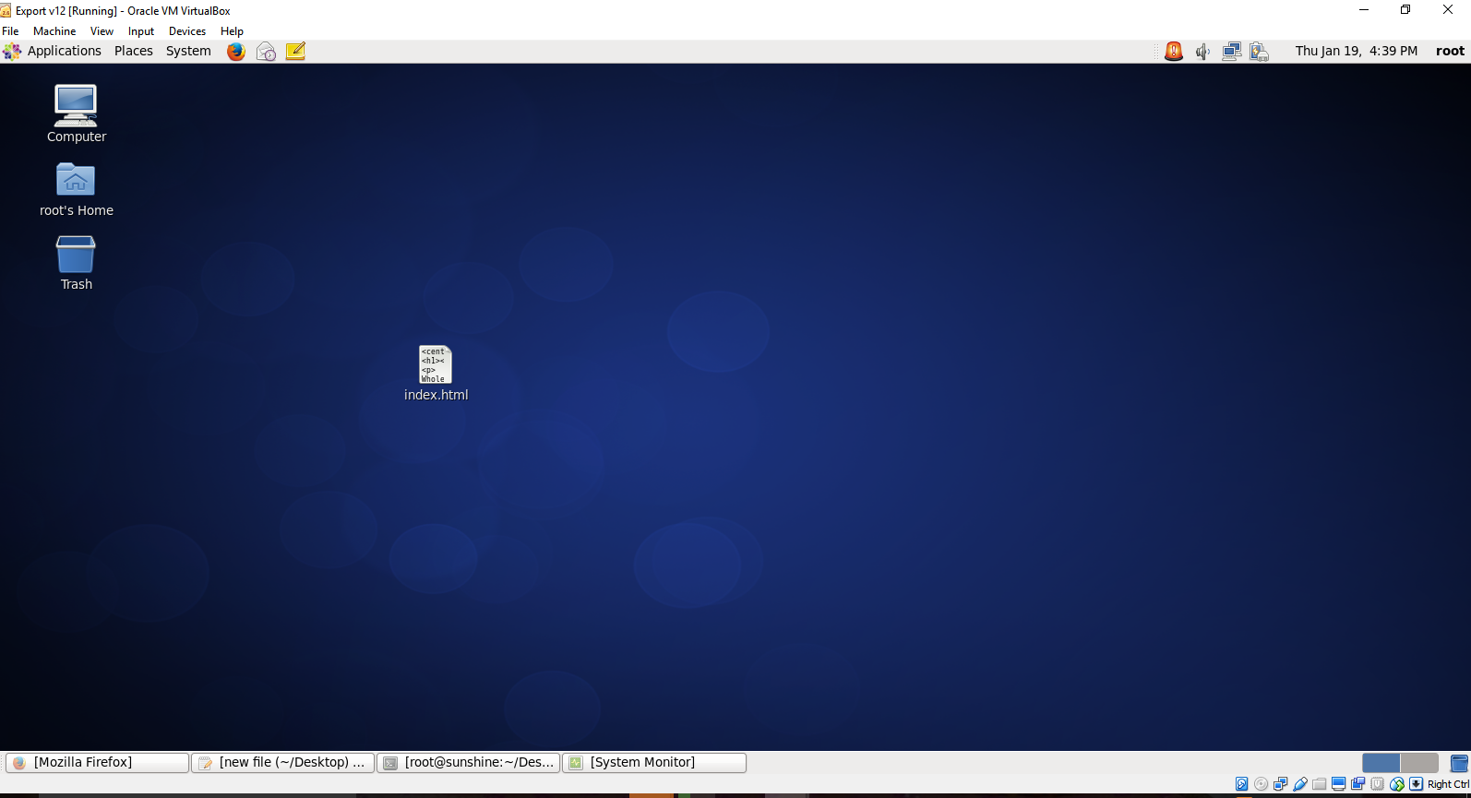

1. A screenshot of the Firefox browser within your CentOS desktop showing your company homepage (10 points)

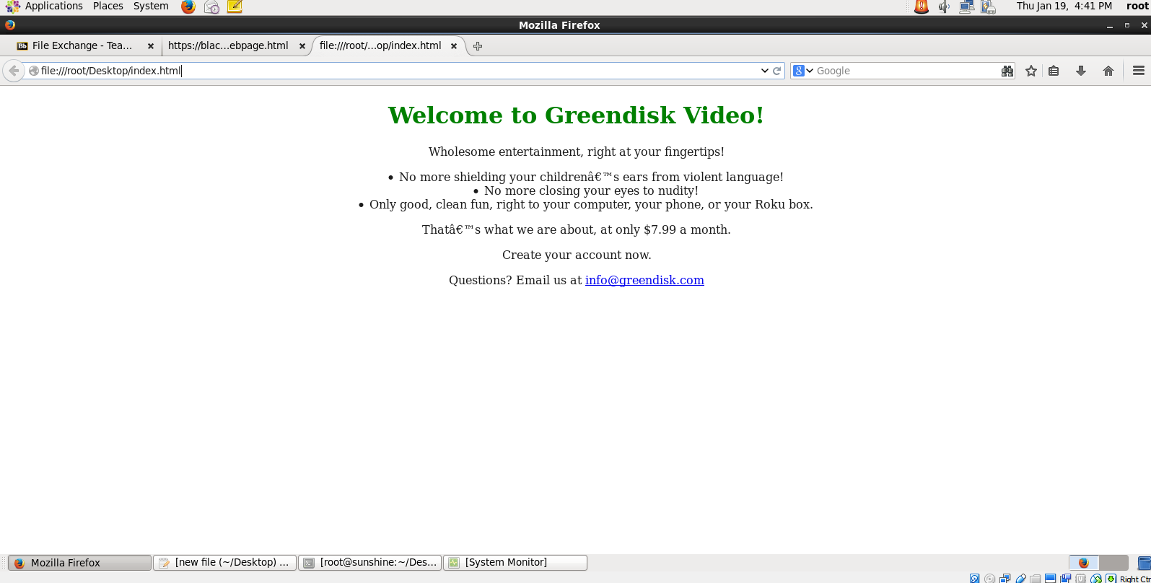

1. A screenshot of the System monitor output (20 points)

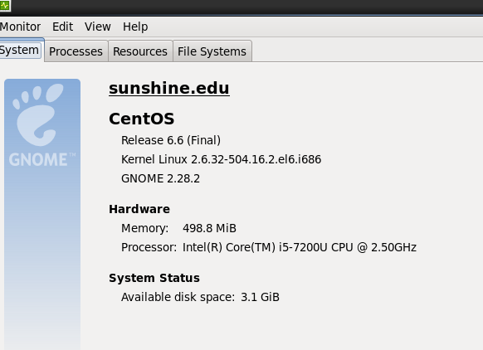

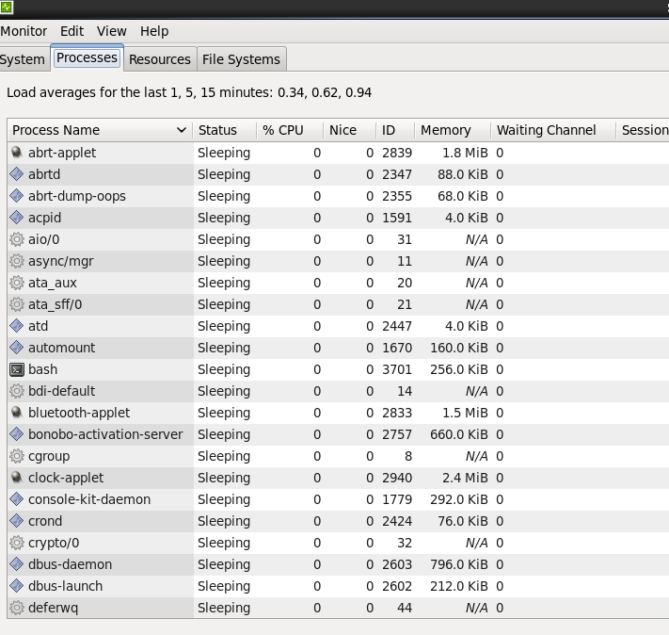

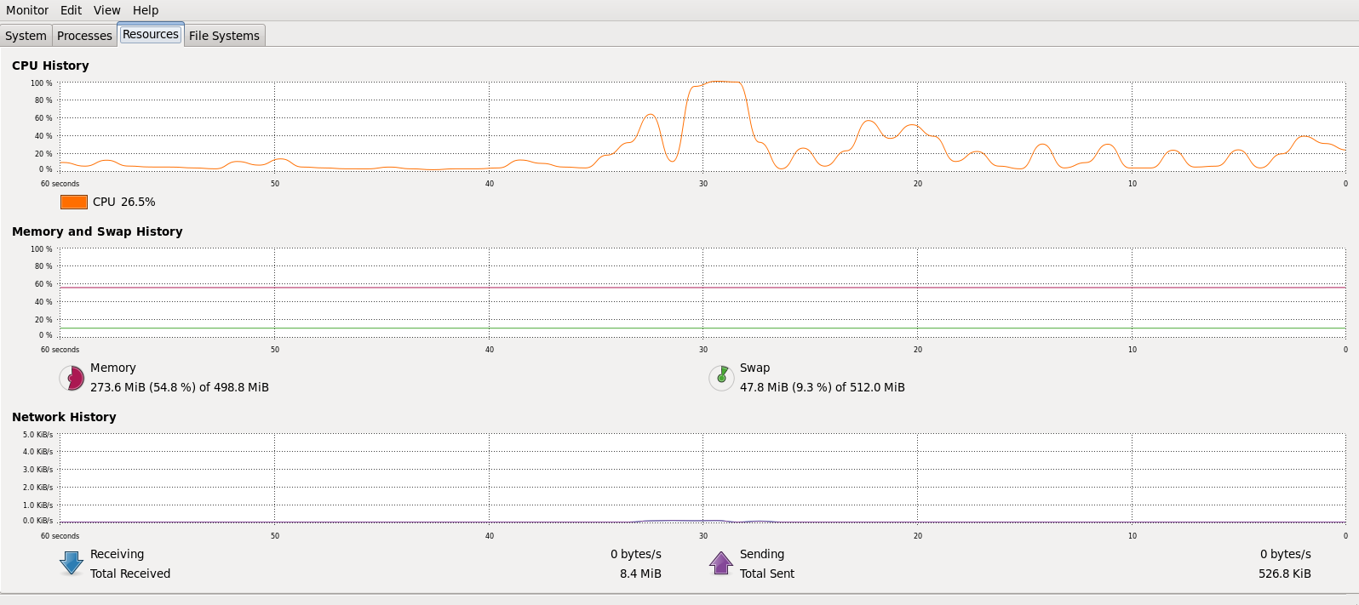

1. A screenshot of the terminal window showing the “whoami” command and its output (10 points)

